Jacob Dineen

IST 722 Data Warehouse

12/6/2017

NetID: Jdineen

Pivot Table:

Exponentially poor lag time on shipping during 1997 per just about every product.

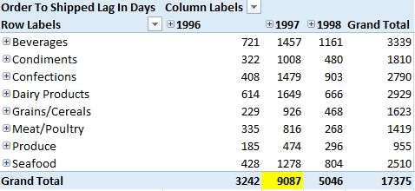

Could be due to the fact that sales were doubled from the previous year and demand couldn’t be kept up with:

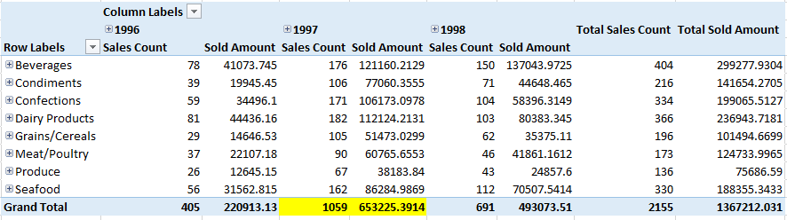

PowerPivot:

Sales by Employees (I tried to put this in PowerView, but I couldn’t get the ribbon to appear on Excel 2016, which seems to be the only year of Office on RemoteLab):

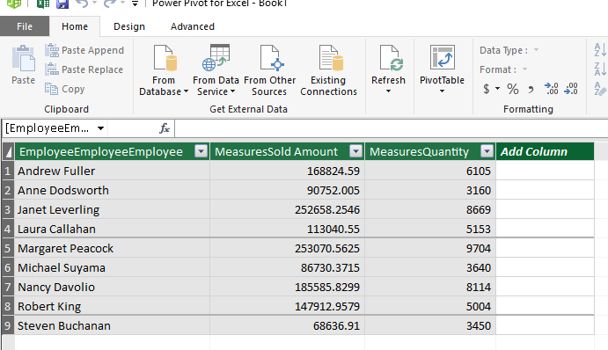

PowerBI Desktop:

Here’s a dashboard showing a doughnut chart for product category, a line chart for sales counts by employees, and a map that shows quantity of product sold and sold amount when hovered over + density of sales is measured by the shade of green. There are two filters at the bottom that control all of these charts – Month and Country.

